UNIVERSITY OF GHANA
DEPARTMENT OF STATISTICS AND ACTUARIAL SCIENCE
ASTA 607
EXAM
ID: 22425124

Question 1:
a.
Input:

?crabs

Output:

Description
The crabs data frame has 200 rows and 8 columns, describing 5 morphological measurements on 50 crabs each of two colour forms and both sexes, of the species Leptograpsus variegatus collected at Fremantle, W. Australia.

b.
Input:

data(crabs)
str(crabs)

Output:

data.frame': 200 obs. of 8 variables:
$ sp : Factor w/ 2 levels "B","O": 1 1 1 1 1 1 1 1 1 1 ...
$ sex : Factor w/ 2 levels "F","M": 2 2 2 2 2 2 2 2 2 2 ...
$ index: int 1 2 3 4 5 6 7 8 9 10 ...
$ FL : num 8.1 8.8 9.2 9.6 9.8 10.8 11.1 11.6 11.8 11.8 ...
$ RW : num 6.7 7.7 7.8 7.9 8 9 9.9 9.1 9.6 10.5 ...
$ CL : num 16.1 18.1 19 20.1 20.3 23 23.8 24.5 24.2 25.2 ...
$ CW : num 19 20.8 22.4 23.1 23 26.5 27.1 28.4 27.8 29.3 ...
$ BD : num 7 7.4 7.7 8.2 8.2 9.8 9.8 10.4 9.7 10.3 ...

c.
Input:

frequency_table<-table(crabs$sp,crabs$sex)
frequency_table

Output:

F M
B 50 50
O 50 50

d.
Input:

barchart_freq <- barplot(frequency_table,
beside = TRUE,
legend.text = TRUE,
col = c("skyblue", "salmon", "lightgreen"))
barchart_freq

Output:

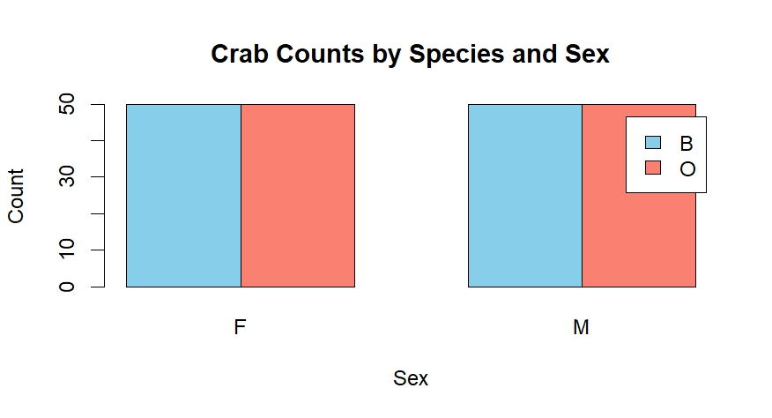
Fig1: Crab Counts by Species and Sex

e. The dataset is balanced across the four groups.

Question 2
a.

Input:

par(mfrow=c(1,2))
boxplot(crabs$sp ~ crabs$sex,
main = "Boxplot of sp by sex")

Output:
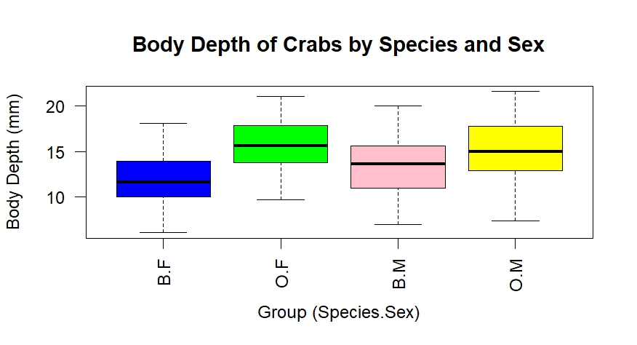
Fig 2: Body Depth of Crabs by species by sex

b.
The boxplot of crab body depth across the four groups defined by species and sex shows that O.F and O.M generally have larger body depths than B.F and B.M. Among the groups, O.F have the highest median body depth, while B.F have the lowest. Variability is greatest in the O.F and O.M, indicated by the longer boxes and whiskers, whereas B.F exhibit the most consistent body depths. No obvious outliers are present in any group. Overall, species differences appear more pronounced than sex differences, with males and females within each species showing only modest differences in central tendency.

Question 3:
a.

Input:

hist(crabs$CL[crabs$sp == "B"],
main="Species B", xlab="Carapace Length", col="blue")

Output:
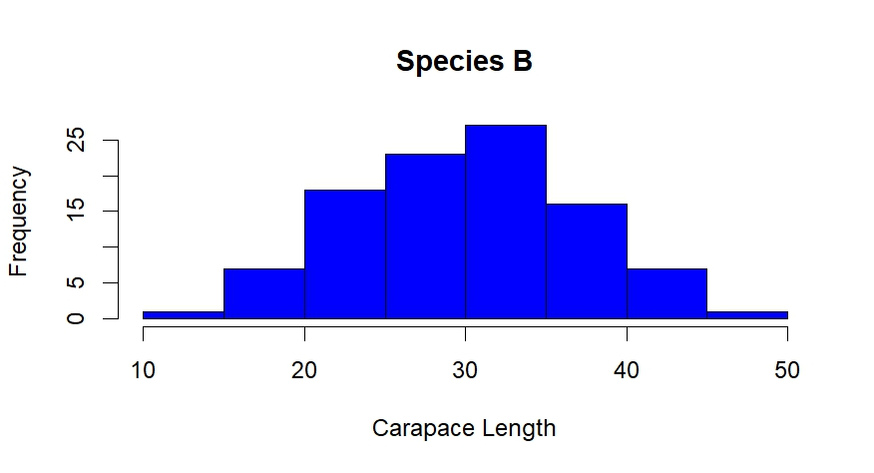

Input:
hist(crabs$CL[crabs$sp == "O"],
main="Species O", xlab="Carapace Length", col="pink")

Output:
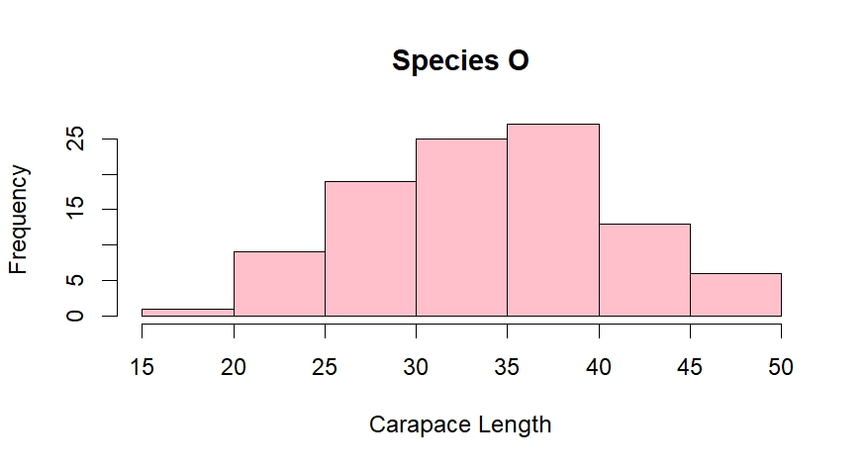

Fig 3: Histograms of Species B and Species O

b.
The histograms show that Species B (blue) has carapace lengths mostly concentrated around higher values, with a fairly symmetric distribution and moderate variability, indicating that individuals of this species are generally larger. In contrast, Species O (pink) displays smaller carapace lengths with a slightly right-skewed distribution and a somewhat wider spread, suggesting more variation in size and a generally smaller body size compared to Species B. Overall, the comparison indicates that Species B tends to be larger and more uniform in size, while Species O exhibits greater diversity and smaller average carapace length.

Question 4:
a.
Input:

mean_each_measurement<-aggregate(cbind(FL, RW, CL, CW, BD) ~ sp + sex, data = crabs, FUN = mean)

mean_each_measurement

output:
sp sex FL RW CL CW BD
1 B F 13.270 12.138 28.102 32.624 11.816
2 O F 17.594 14.836 34.618 39.036 15.632
3 B M 14.842 11.718 32.014 36.810 13.350
4 O M 16.626 12.262 33.688 37.188 15.324

b.
Input:

# Prepare a matrix for barplot: rows = measurements, columns = groups
# combine species and sex into one factor
means_matrix <- t(as.matrix(mean_each_measurement[, 3:7])) # take only the measurement columns and transpose

# Create bar labels combining species and sex
group_labels <- paste(mean_each_measurement$sp, mean_each_measurement$sex, sep = "-")

# Plot grouped bar chart
barplot(means_matrix, beside = TRUE, col = rainbow(nrow(means_matrix)),
names.arg = group_labels, las = 2,
main = "Mean Measurements of Crabs by Species and Sex",
ylab = "Mean Value")
legend("topright", legend = rownames(means_matrix),
fill = rainbow(nrow(means_matrix)))

Output:
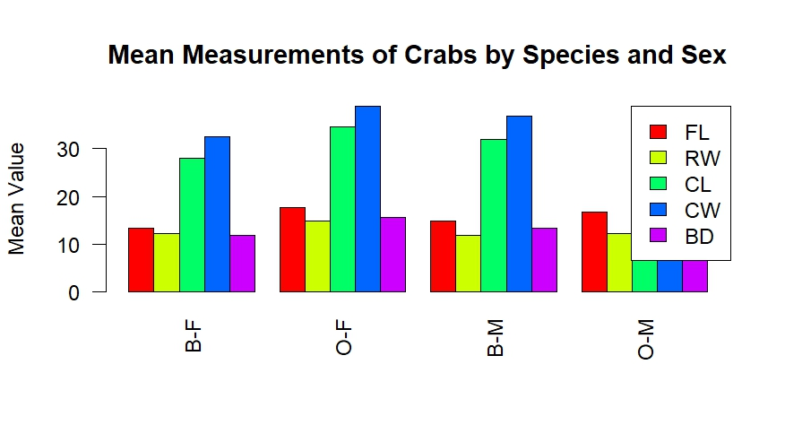

Fig 4: Mean measurements of Crabs by Species and Sex

c.
Measurement CW shows the greatest species difference and RW shows the least sex variation.

Question 5:
a.
Input:

pairs(crabs[, c("FL", "RW", "CL", "CW", "BD")],
main = "Scatterplot Matrix of Crab Measurements",
pch = 19,
col = crabs$sex)
legend("topright", legend = levels(crabs$sex), col = 1:2, pch = 19)

Output:

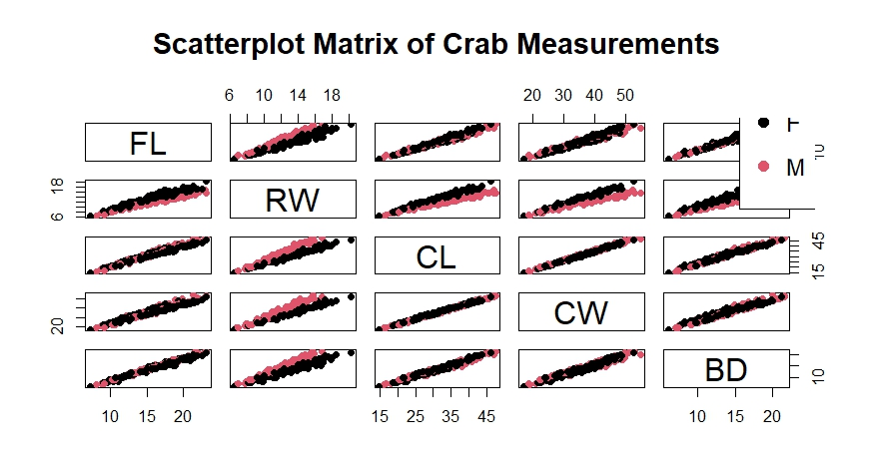
Fig 5: Scatterplot Matrix of Crab Measurements

b.
There are positively significant relationship among all the variables.

Question 6:

The crabs data frame has 200 rows and 8 columns, describing 5 morphological measurements on 50 crabs each of two colour forms and both sexes, of the species Leptograpsus variegatus collected at Fremantle, W. Australia. The structure of the measurements (FL, RW, CL, CW, BD) are numeric, sex and sp are factors, index is integers. The crabs dataset is balanced across the four groups.
The boxplot of crab body depth across the four groups defined by species and sex shows that O.F and O.M generally have larger body depths than B.F and B.M. Among the groups, O.F have the highest median body depth, while B.F have the lowest. Variability is greatest in the O.F and O.M, indicated by the longer boxes and whiskers, whereas B.F exhibit the most consistent body depths. No obvious outliers are present in any group. Overall, species differences appear more pronounced than sex differences, with males and females within each species showing only modest differences in central tendency.
Furthermore, the histograms show that Species B has carapace lengths mostly concentrated around higher values, with a fairly symmetric distribution and moderate variability, indicating that individuals of this species are generally larger. In contrast, Species O displays smaller carapace lengths with a slightly right-skewed distribution and a somewhat wider spread, suggesting more variation in size and a generally smaller body size compared to Species B. Overall, the comparison indicates that Species B tends to be larger and more uniform in size, while Species O exhibits greater diversity and smaller average carapace length. Lastly, measurement CW shows the greatest species difference and RW shows the least sex variation.

